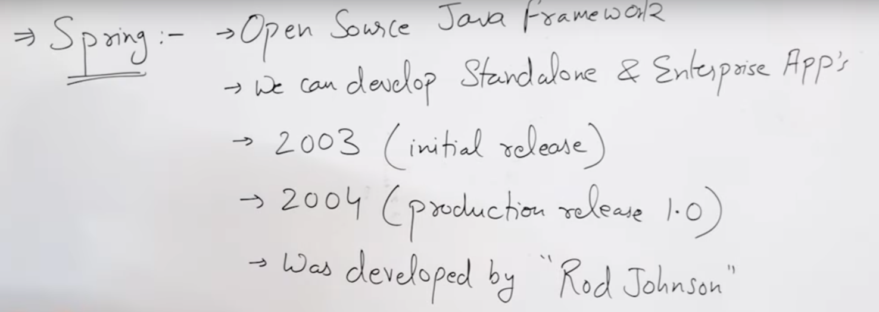

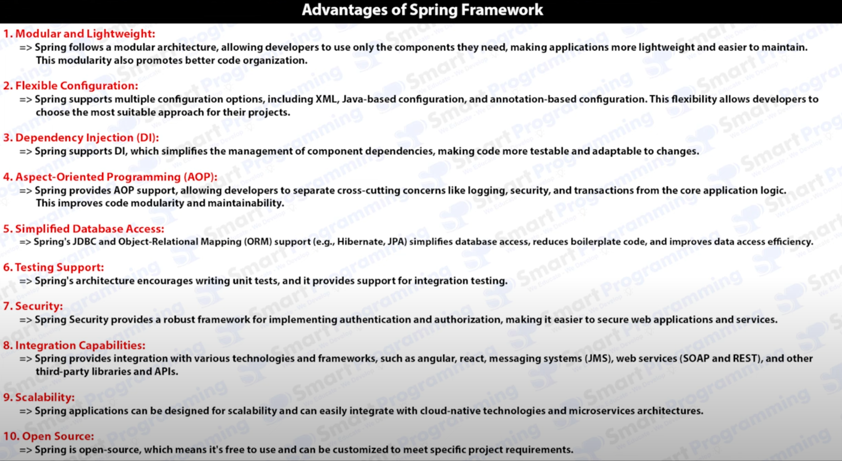

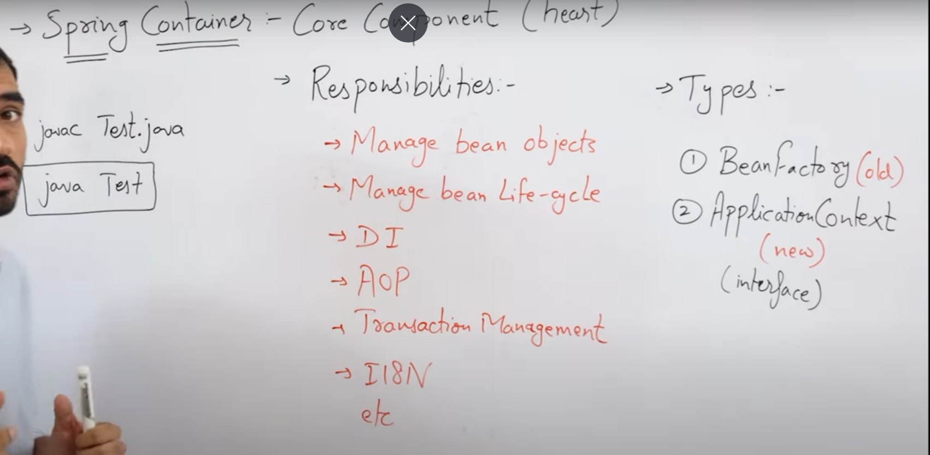

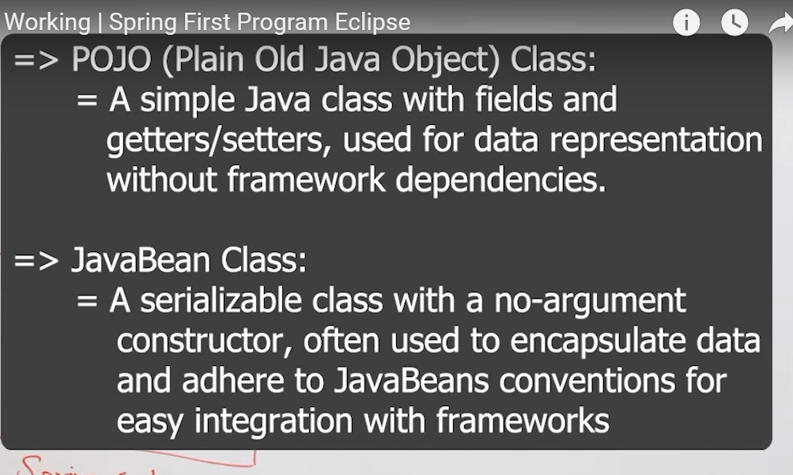

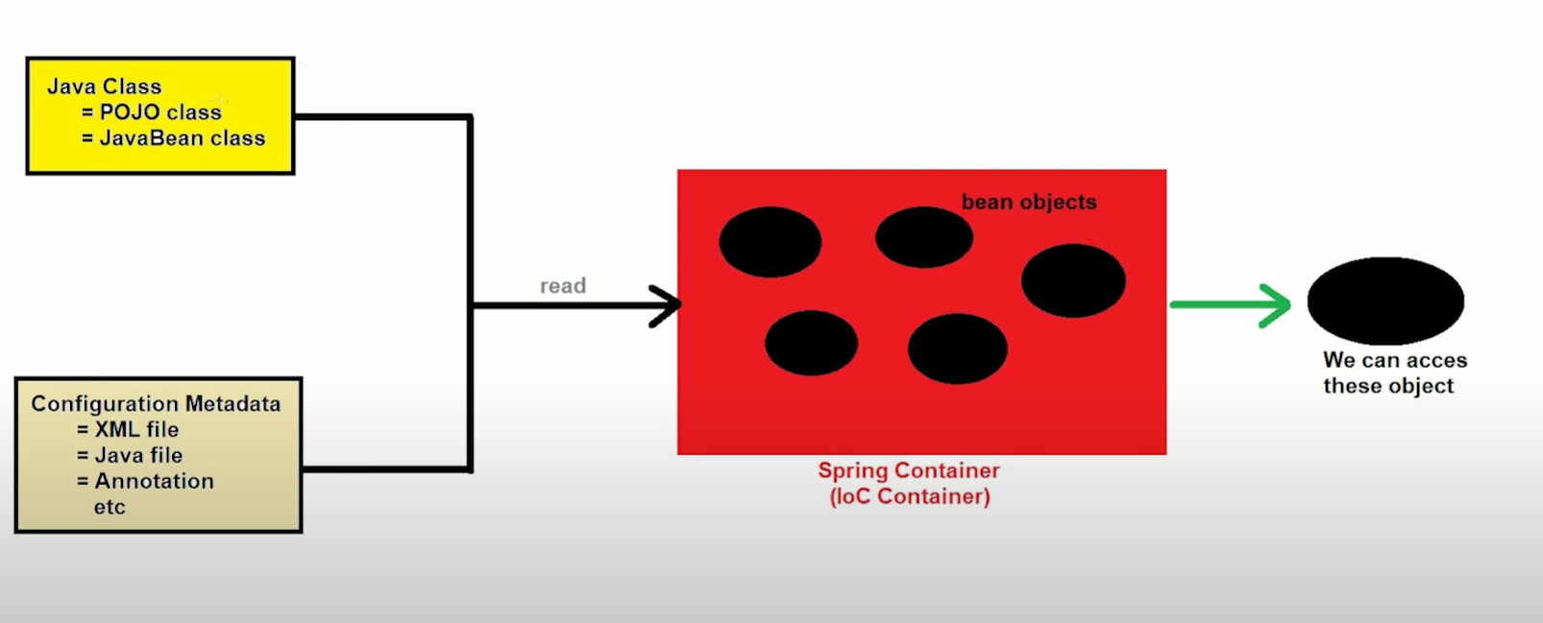

 🡺 POJO class

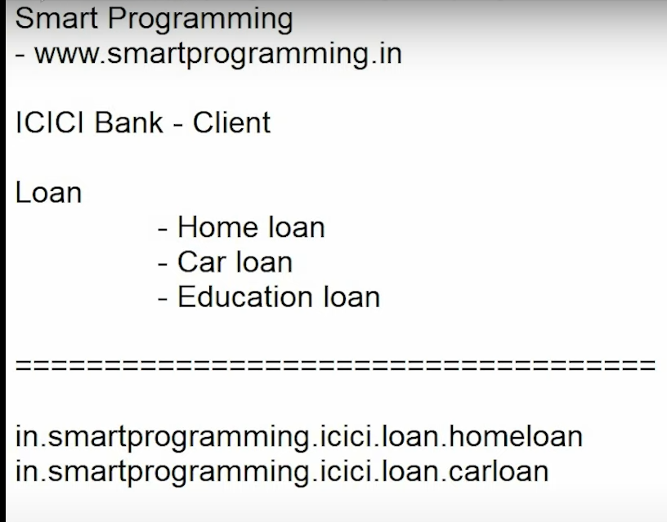 Good way to create package’s

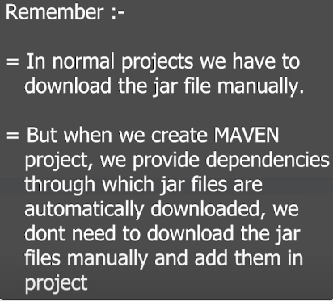 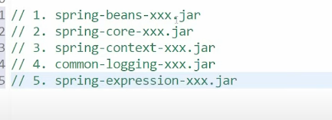

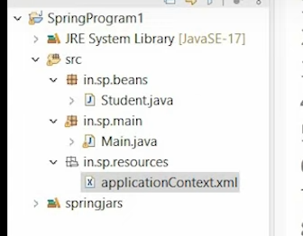

**Creating simple spring program:**

1. XML Configuration metadata

Firstly create POJO files then, create the xml file then in Main class use the ApplicationContext interface to create object of that class.

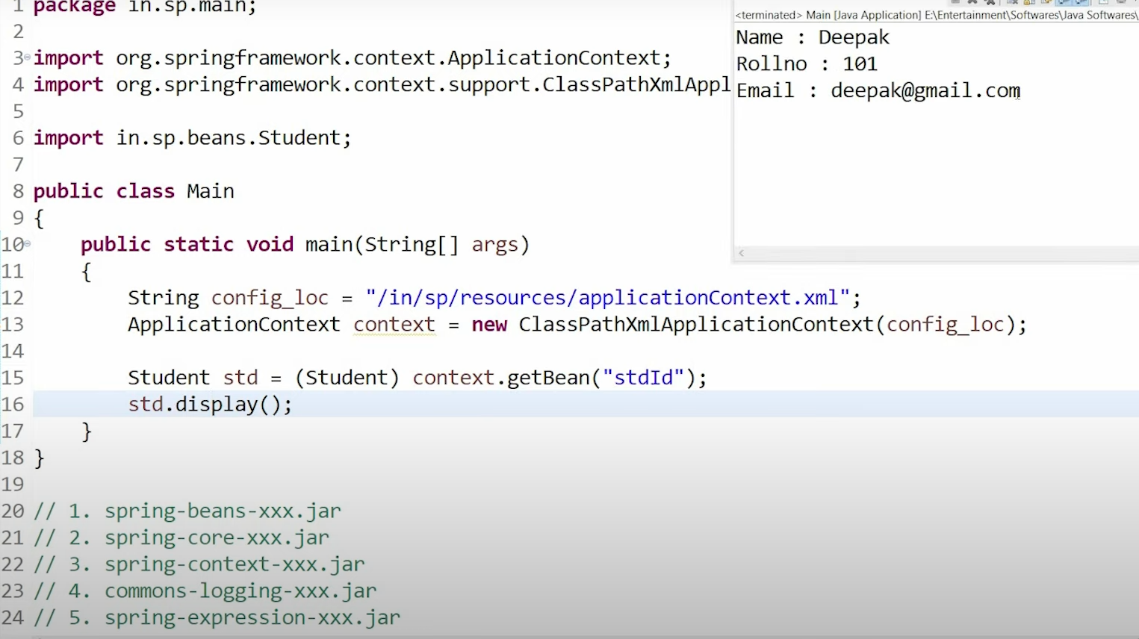

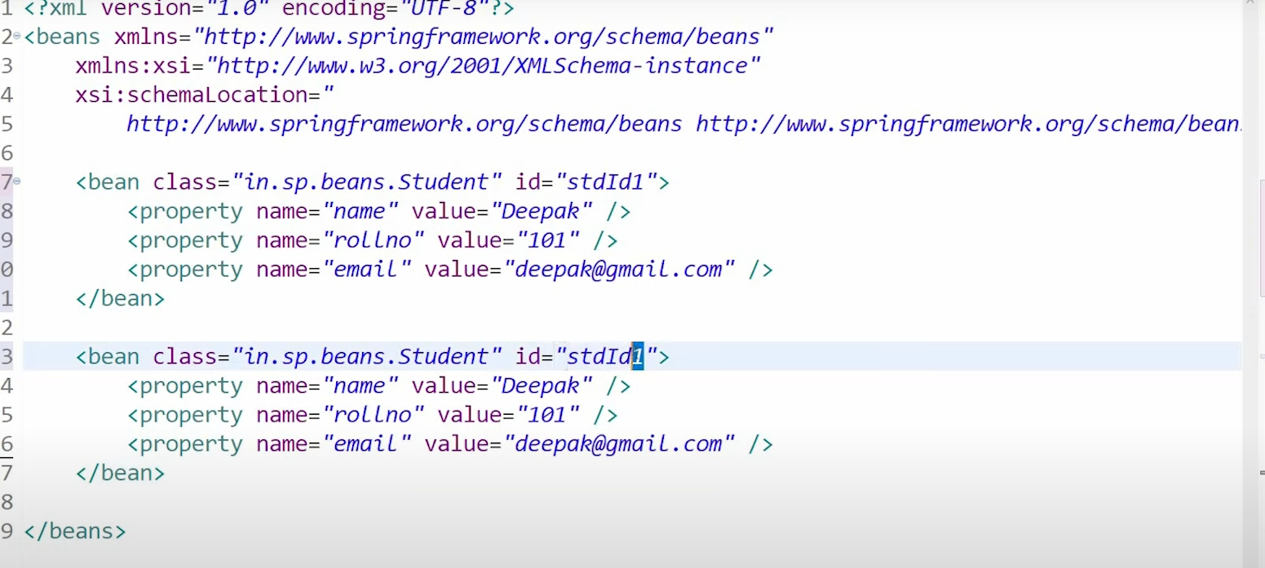

1. Java Configuration metadata

Firstly we need extra jar file which is AOP jar file.

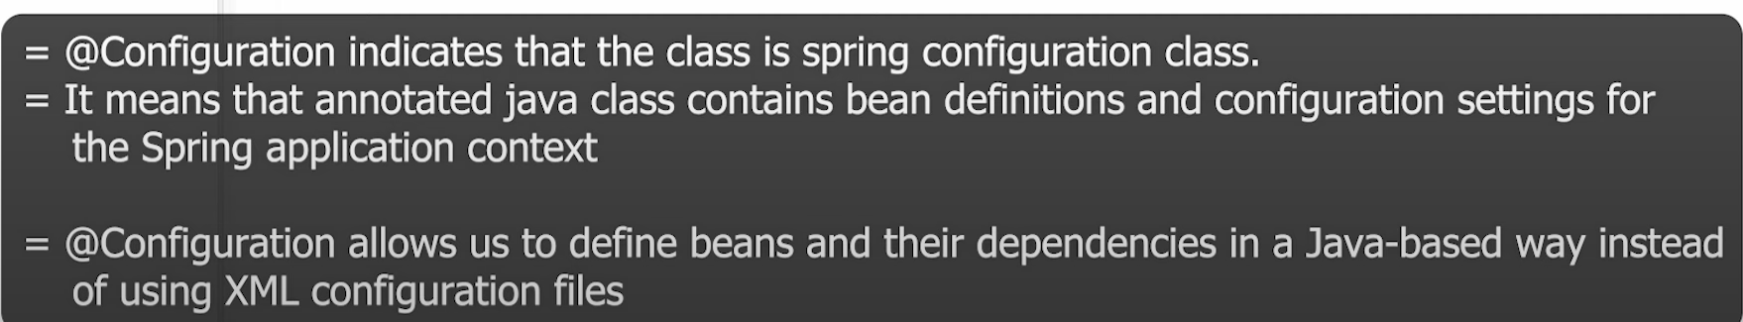

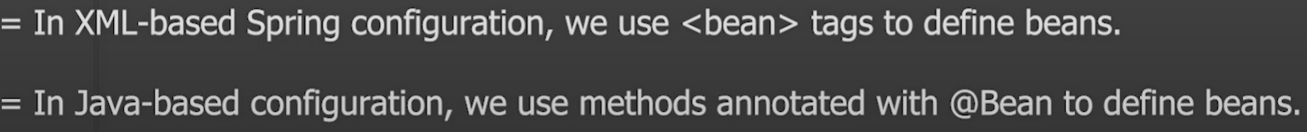

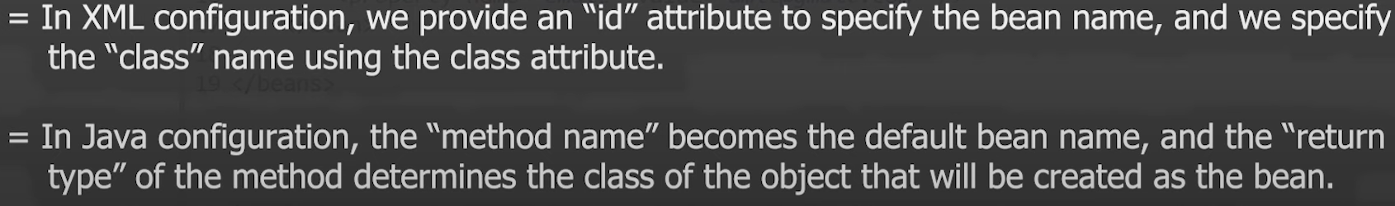

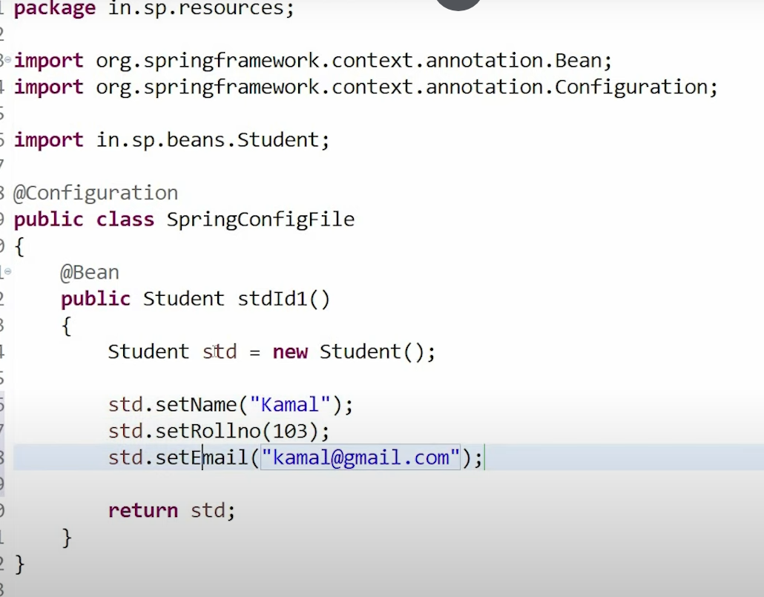

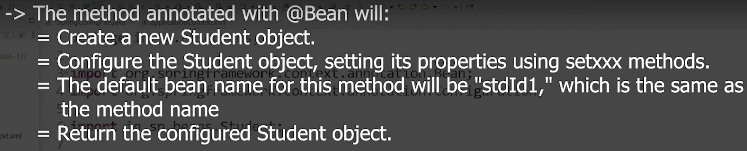

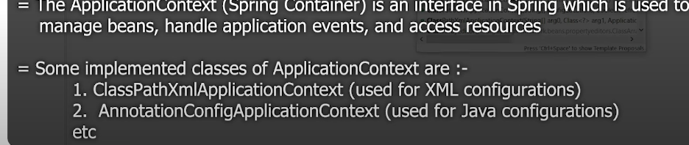

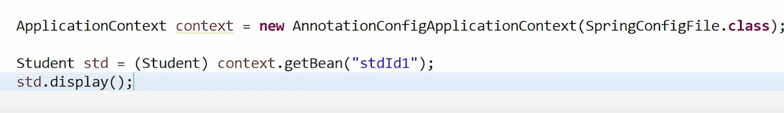

Add the jar file 🡪 spring aop jar file

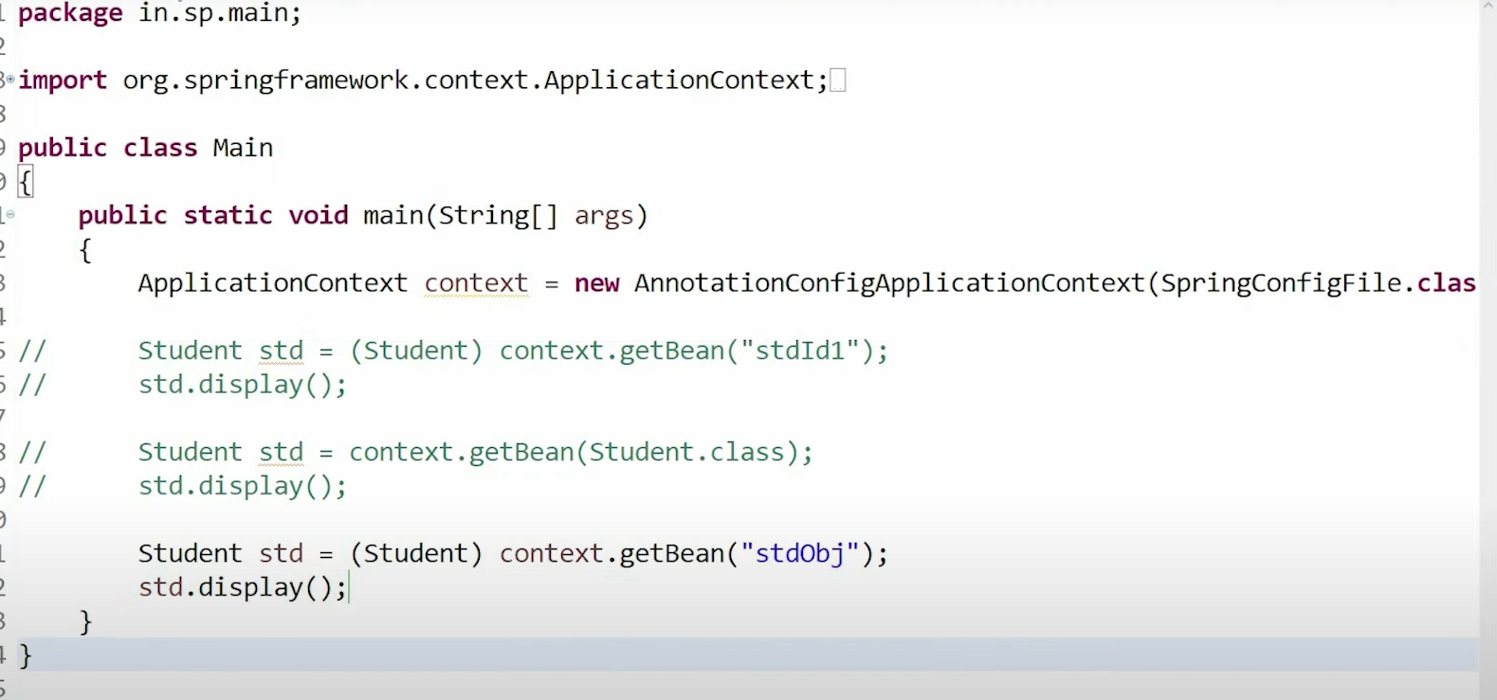

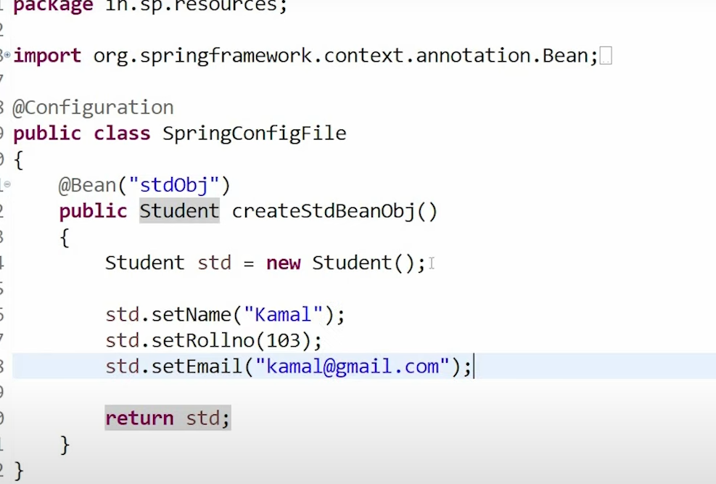

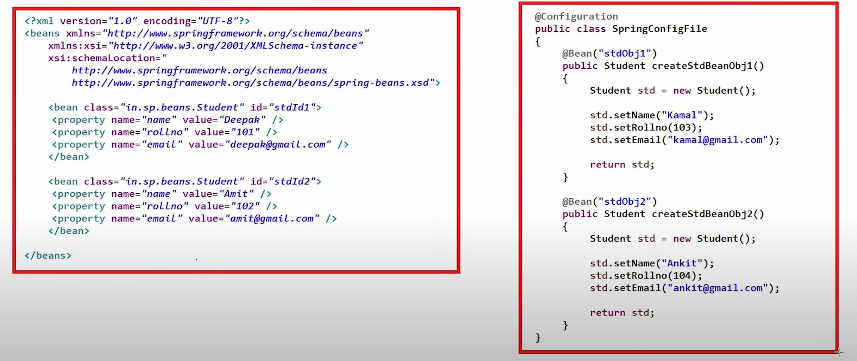

1. Annotation Configuration metadata

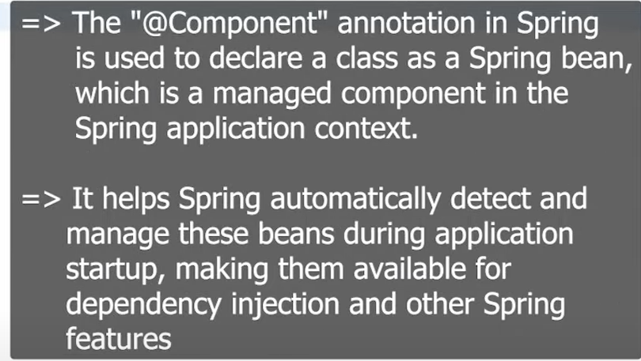

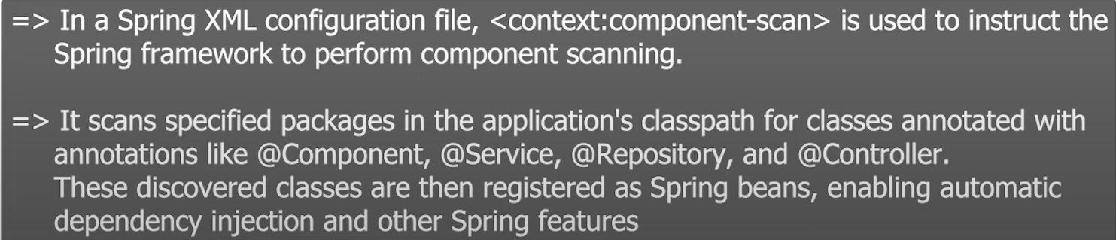

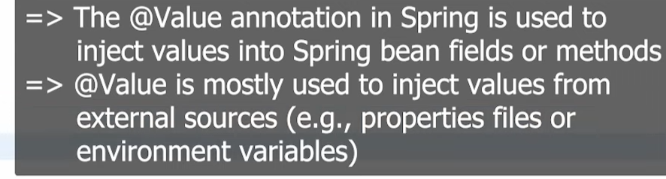

The context Schema

<?xml version="1.0" encoding="UTF-8"?>

<beans xmlns="http://www.springframework.org/schema/beans"

xmlns:xsi="http://www.w3.org/2001/XMLSchema-instance"

*xmlns:context="http://www.springframework.org/schema/context"* xsi:schemaLocation="

http://www.springframework.org/schema/beans http://www.springframework.org/schema/beans/spring-beans.xsd

*http://www.springframework.org/schema/context http://www.springframework.org/schema/context/spring-context.xsd"*> *<!-- bean definitions here -->*

</beans>

Student.java

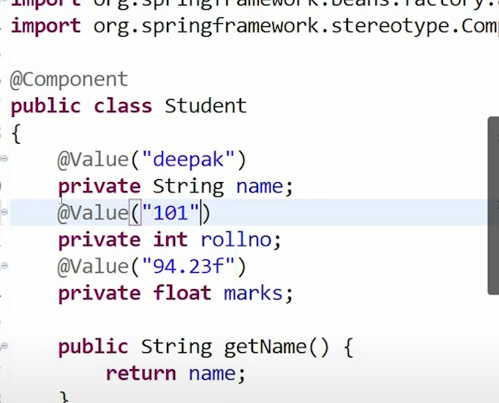

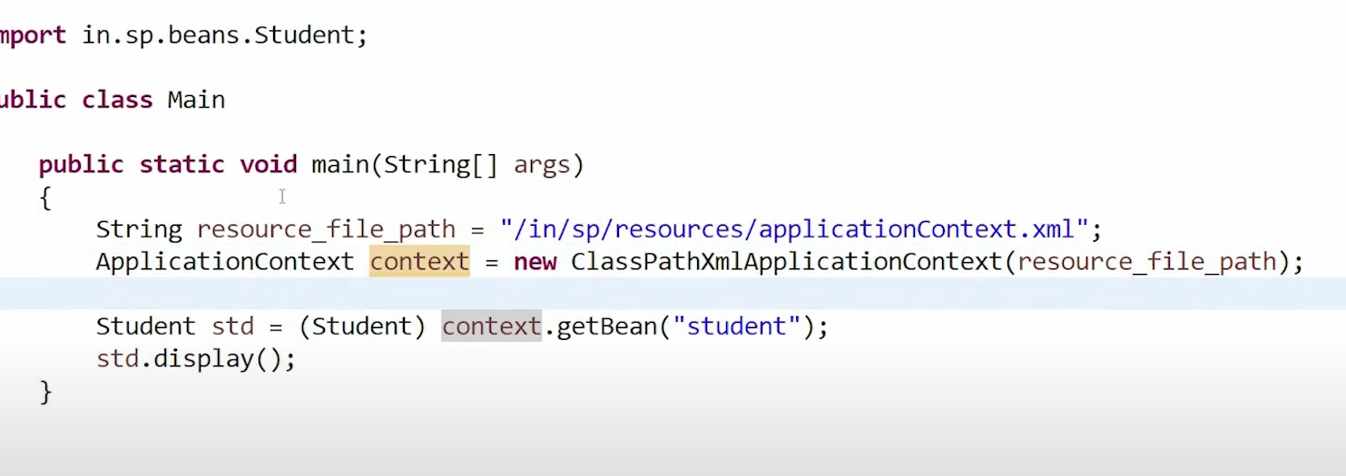

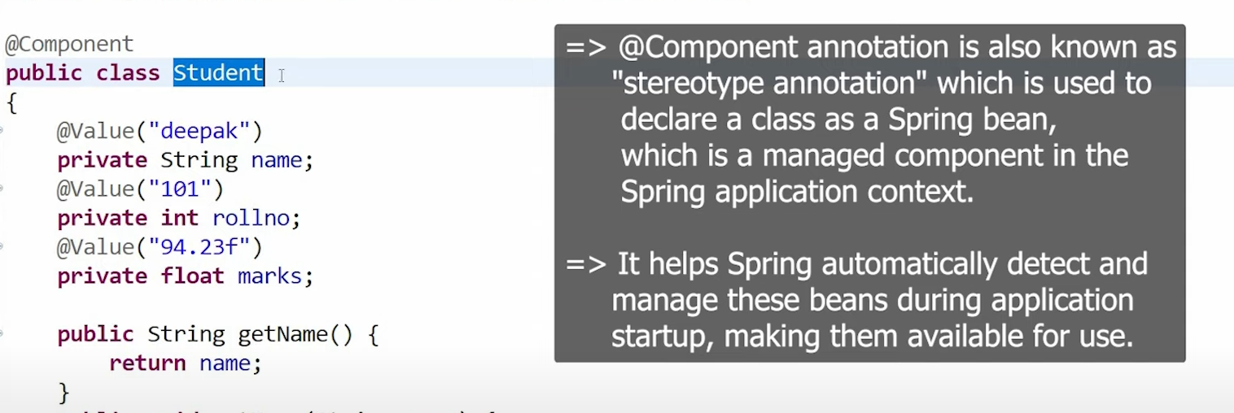

**Life Cycle of Java Bean Object**



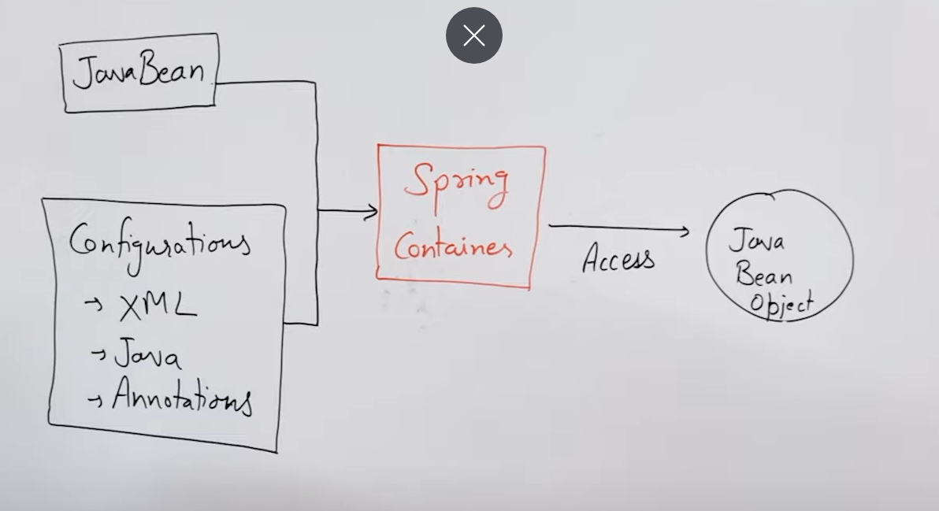

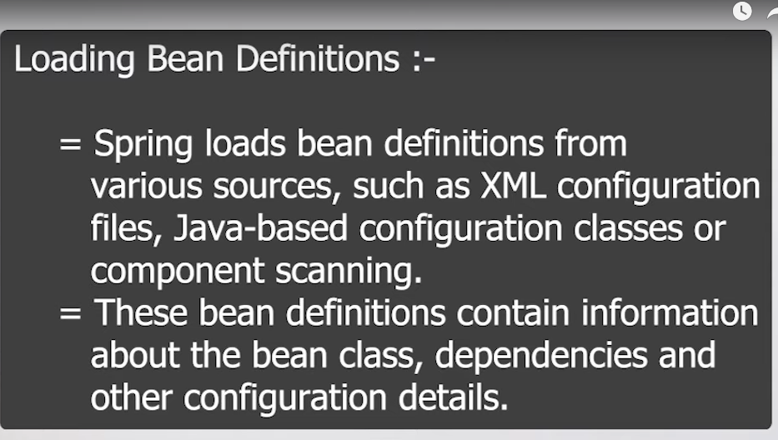

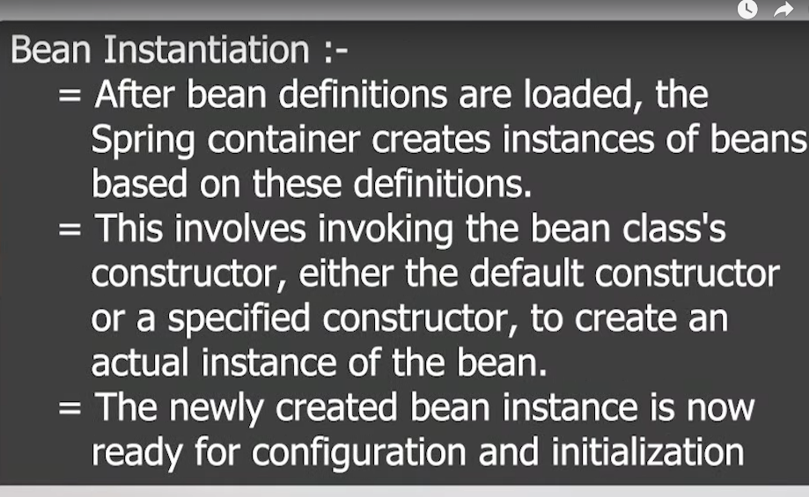

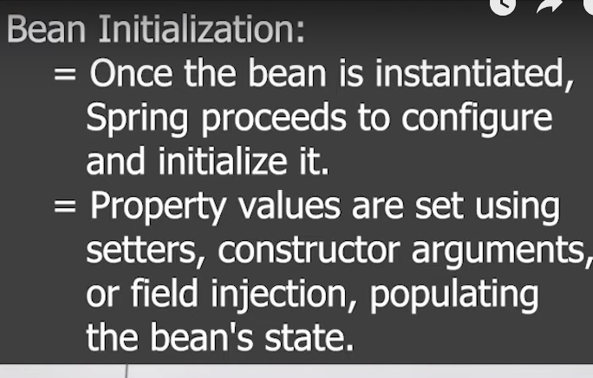

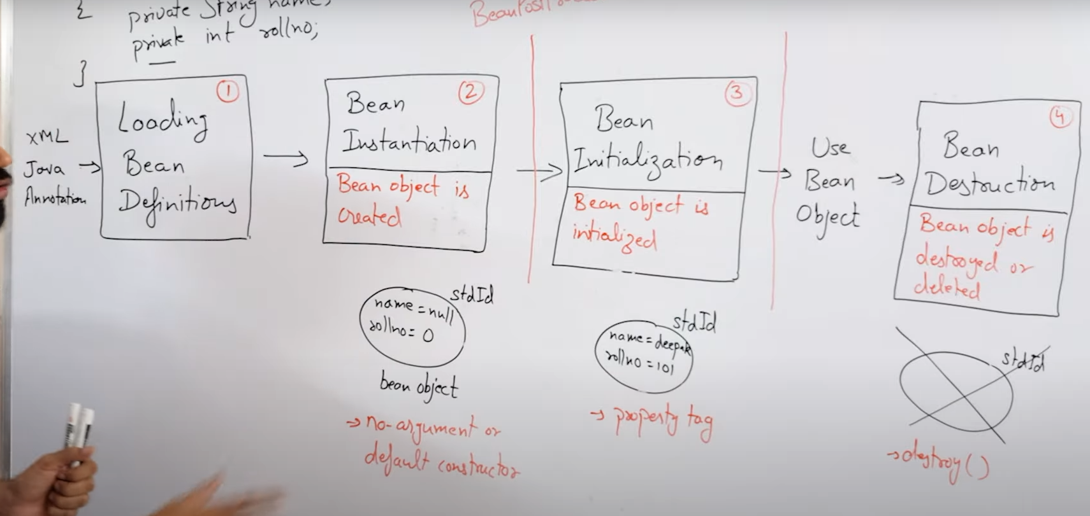



**Dependency Injection**

Depedency Injection

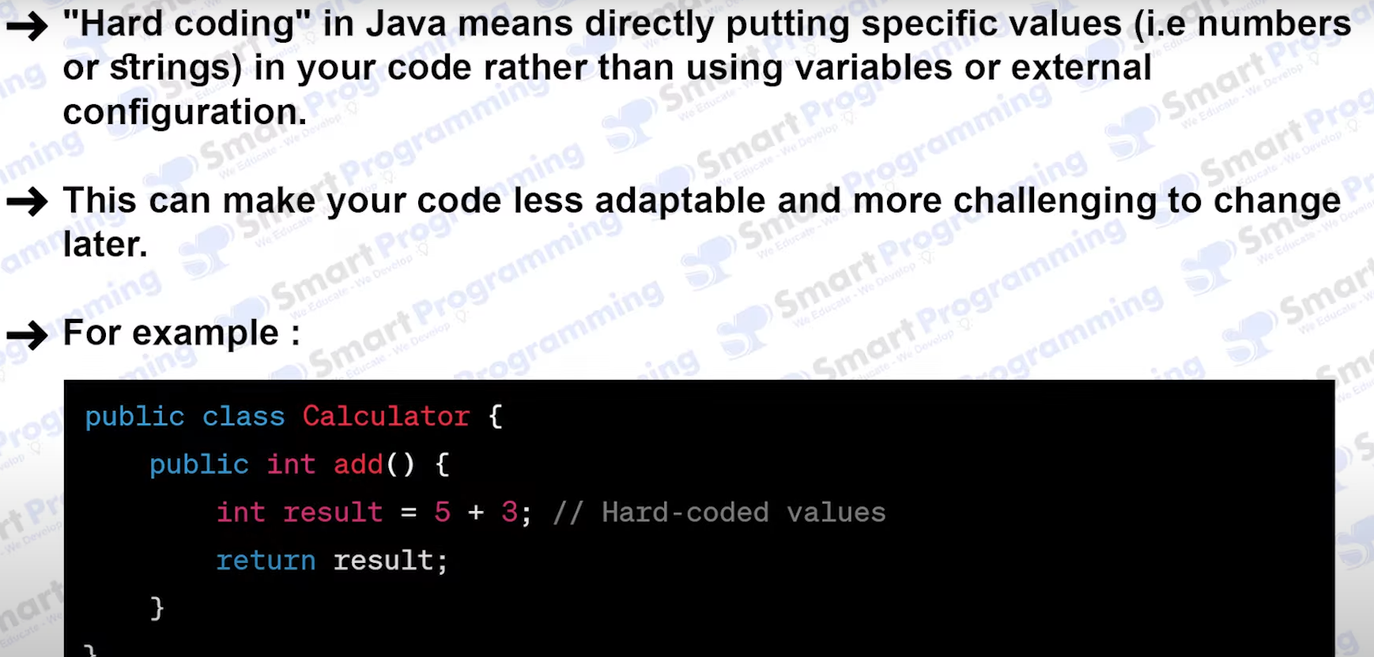

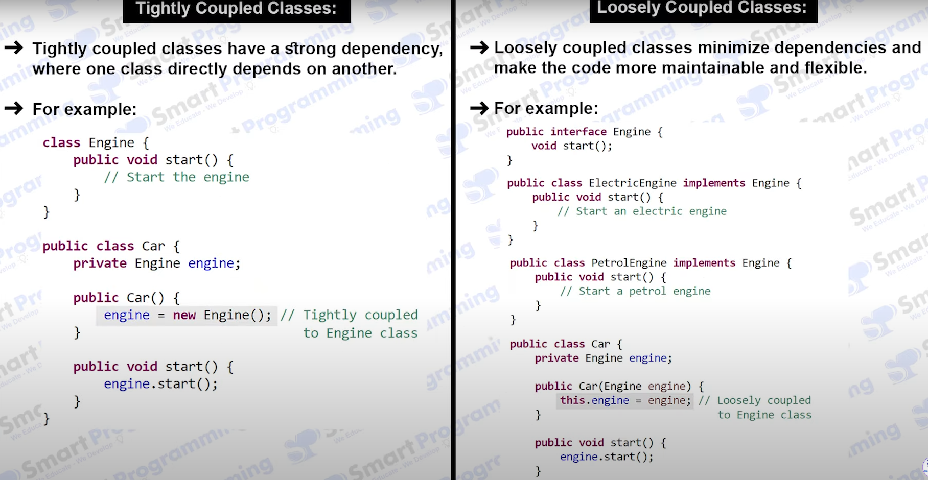

class Student {

private String name;

private String roll;

private Address address; //object of class Address

}

Student std = new Student(“Rajdip”, 01, new Address(“India”)); //this tightly coupled

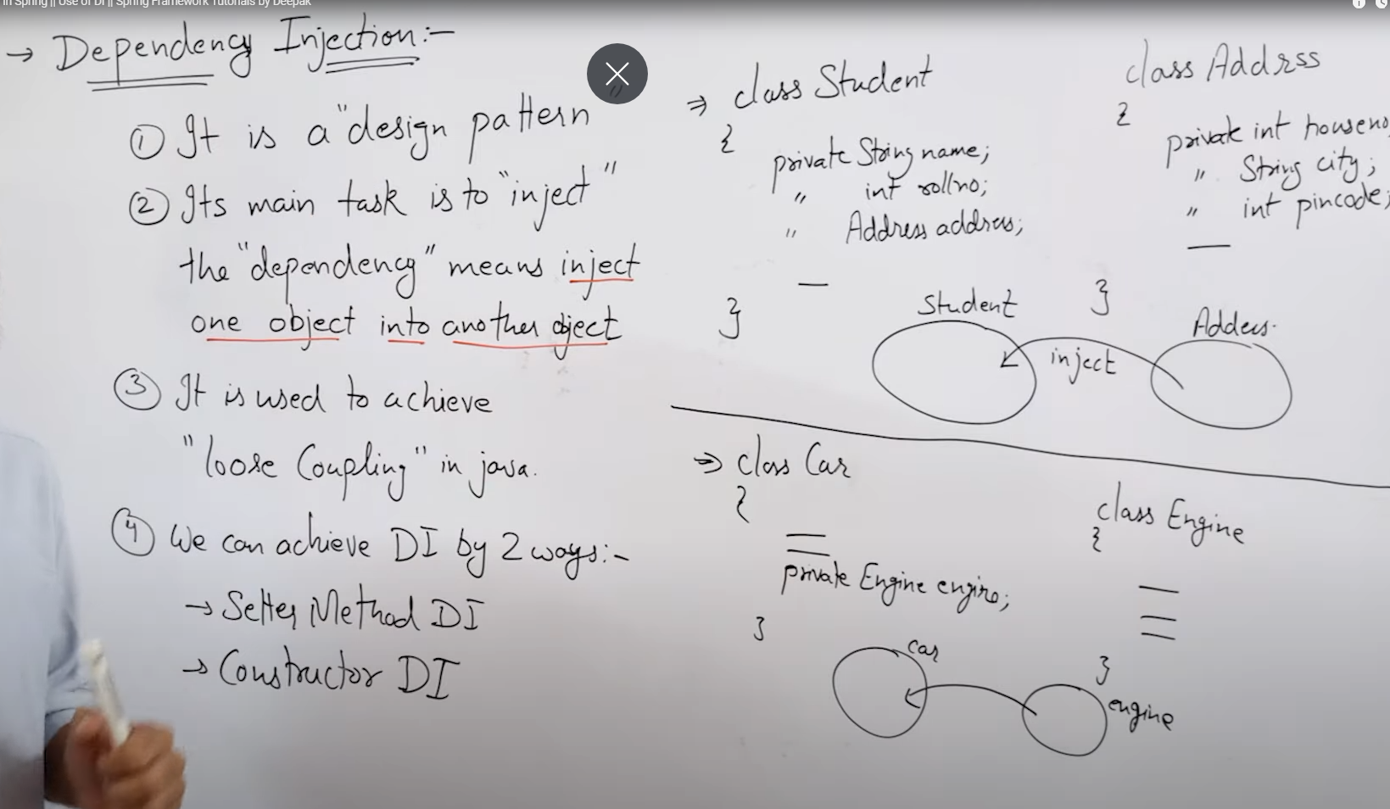

In xml based configuration we are using 🡪

Setter methods and property tags for setter method dependency injection

Constructor and constructor-arg for constructor dependency injection

**Setter method dependency injection**

**Bean class have getter and setter methods**

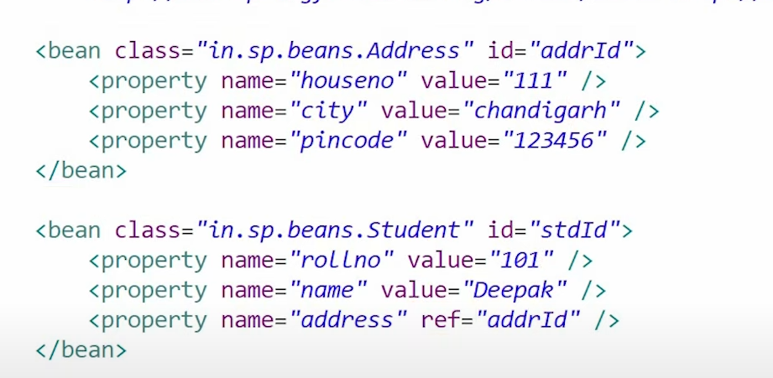

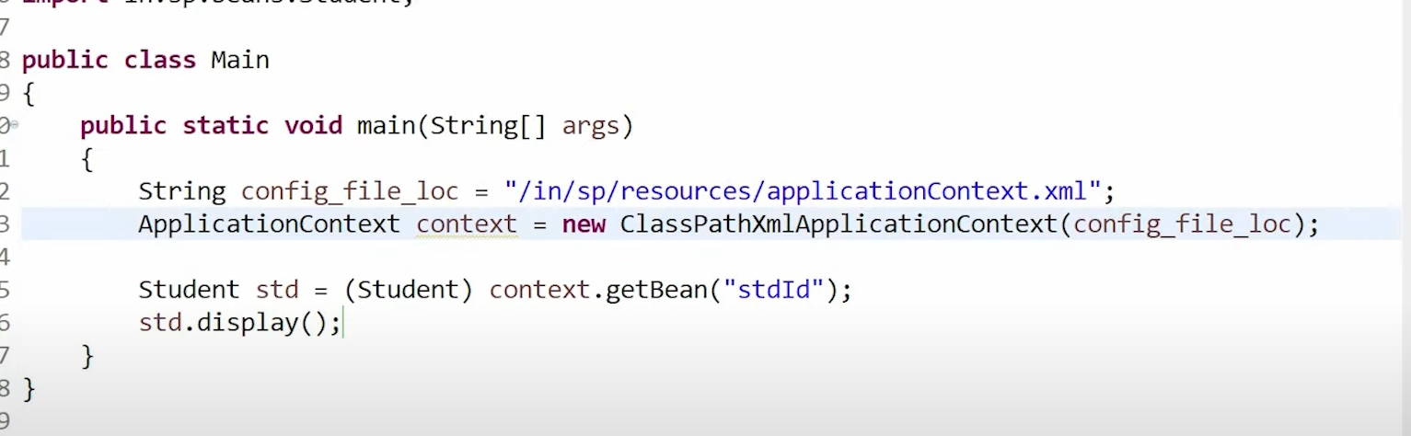

We don’t need to do getBean for address also.

Override the toString for address as we are printing it.

**Constructor dependency injection**

Bean class have constructor.

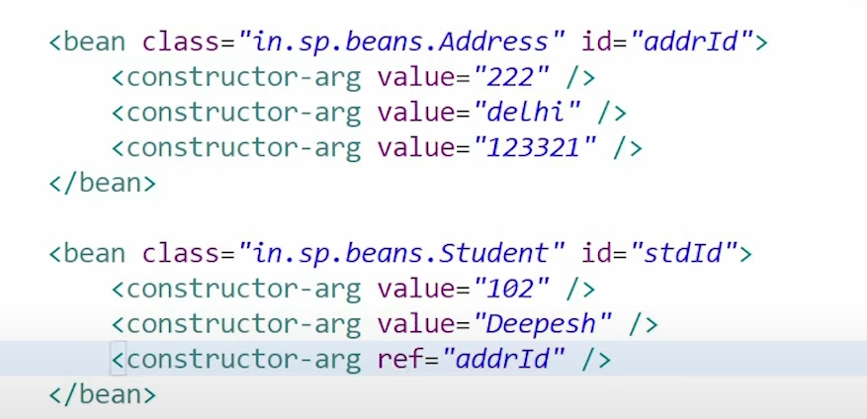

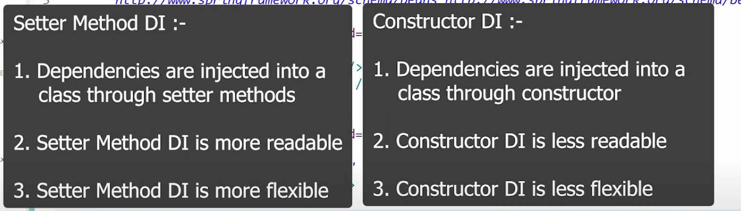

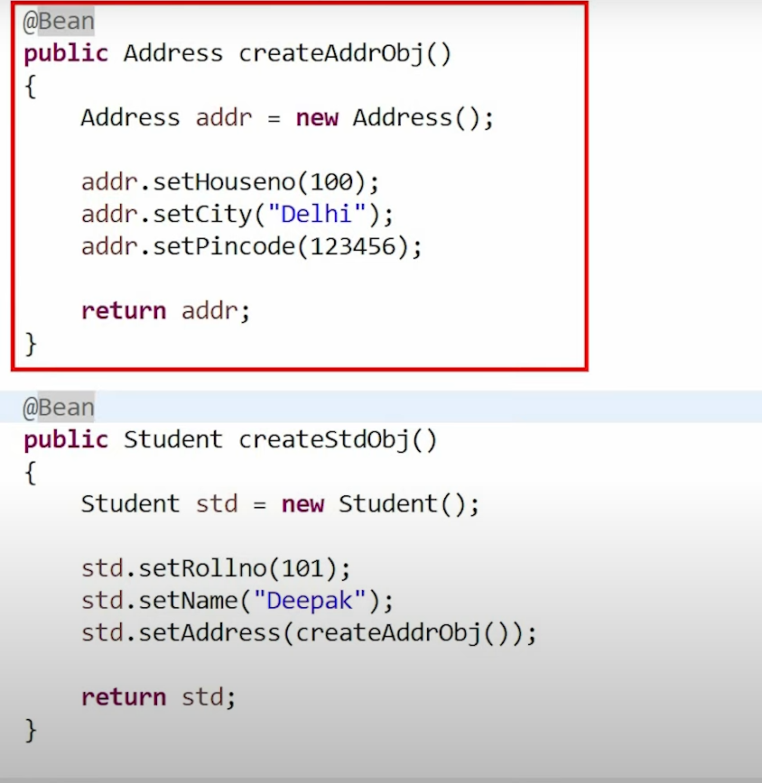

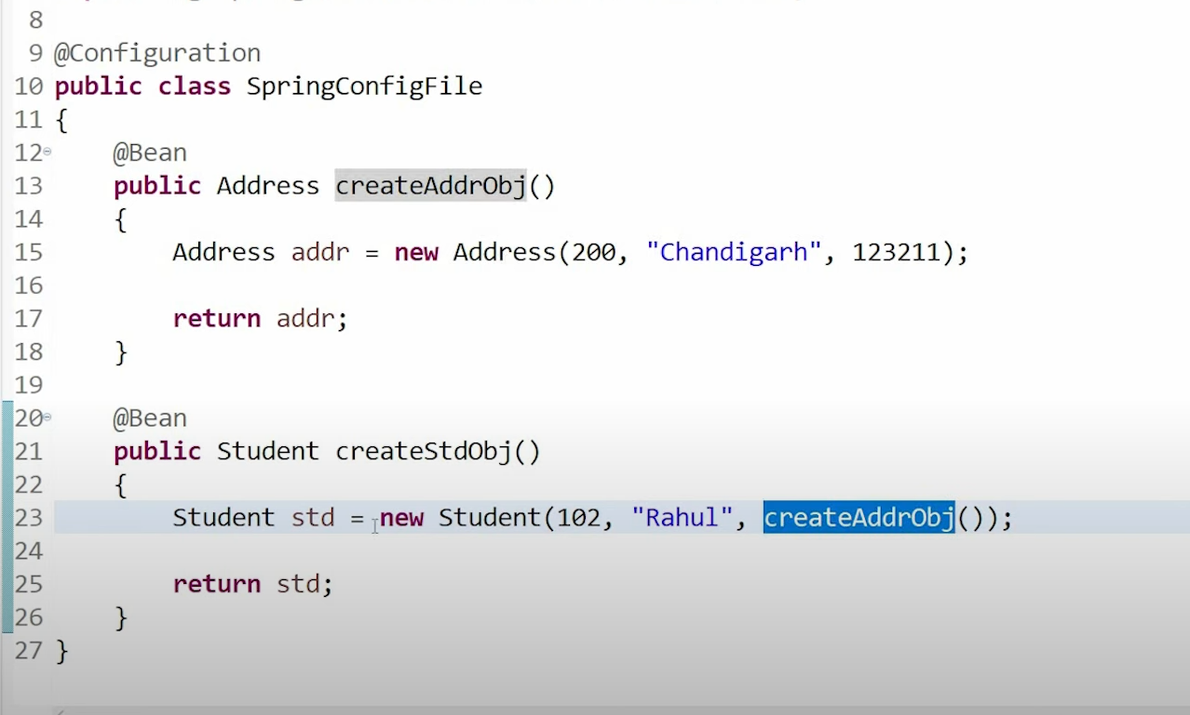

createAddObj() 🡪 This is manual DI

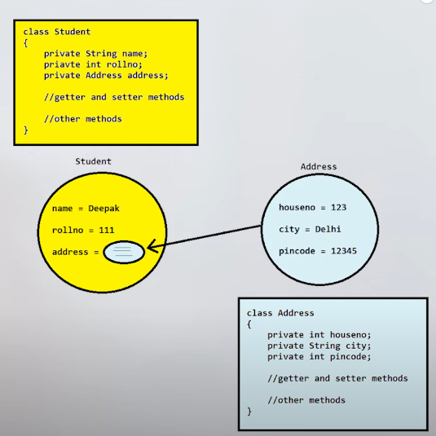 DI

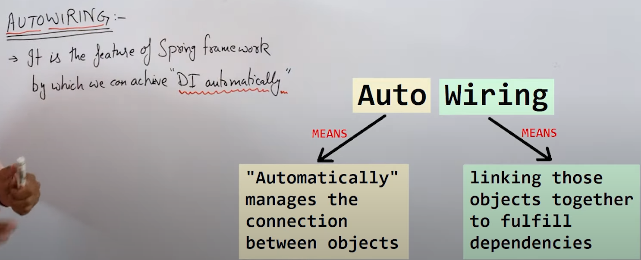

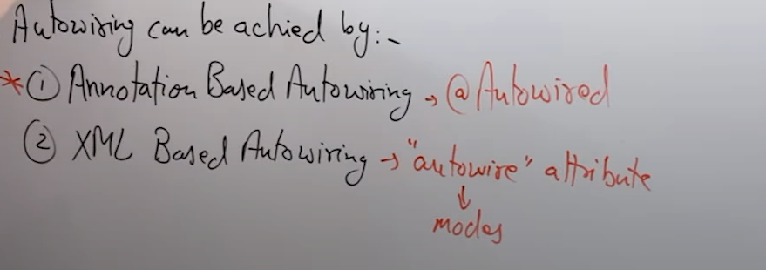

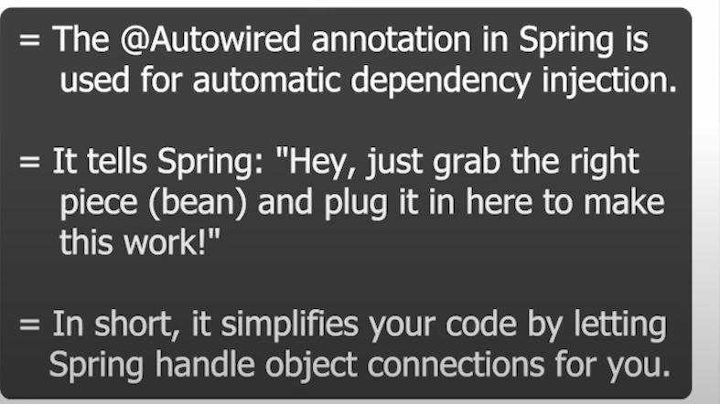

createAddObj() 🡪 Manual DI

For auto wiring you just have to write @Autowired before the object reference.

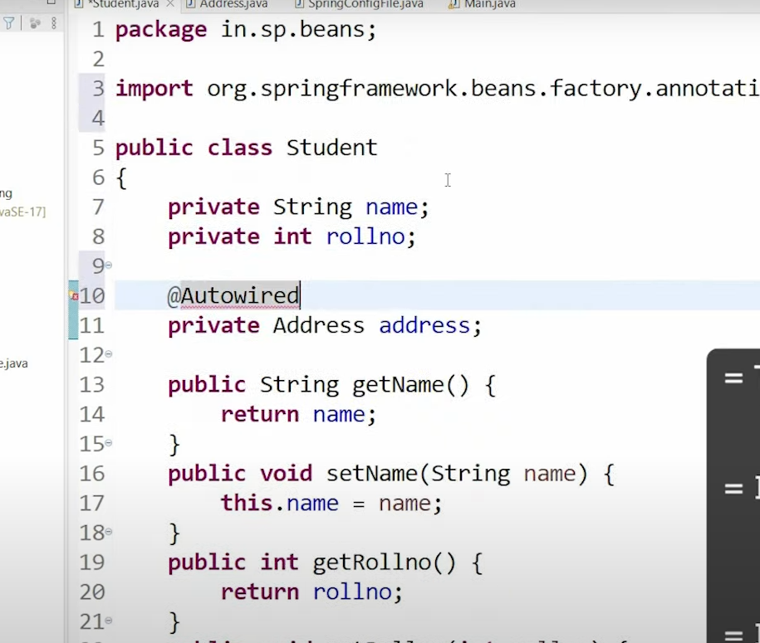

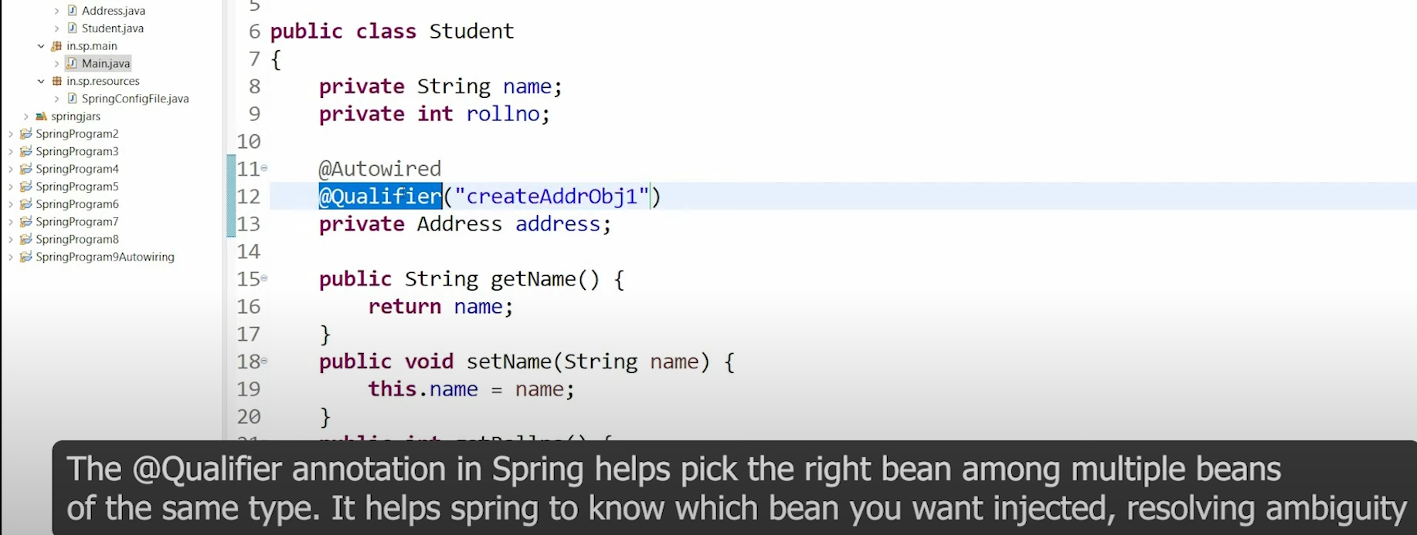

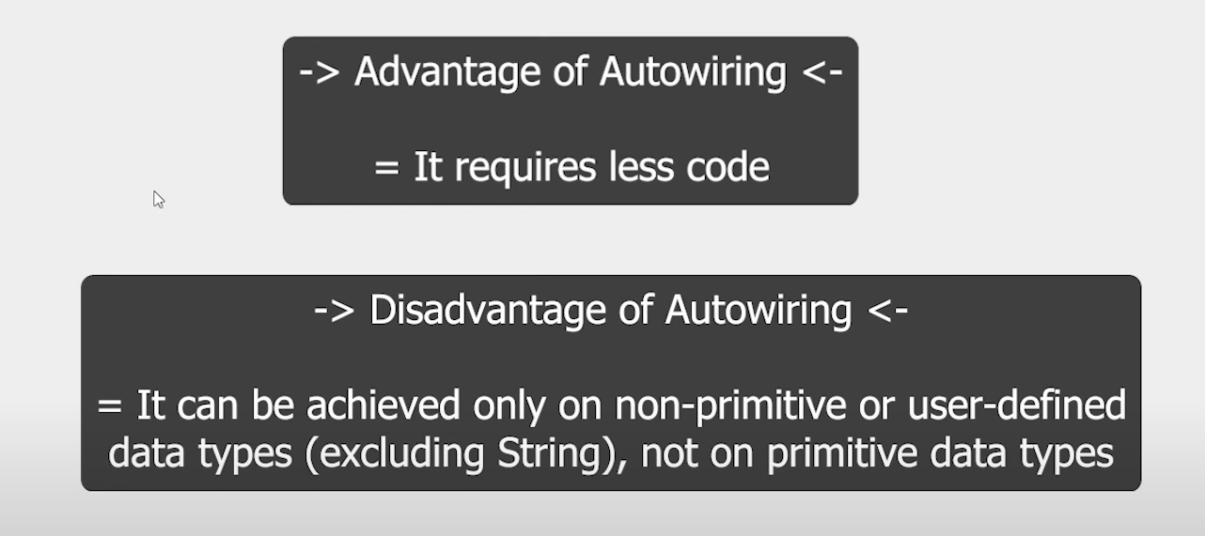

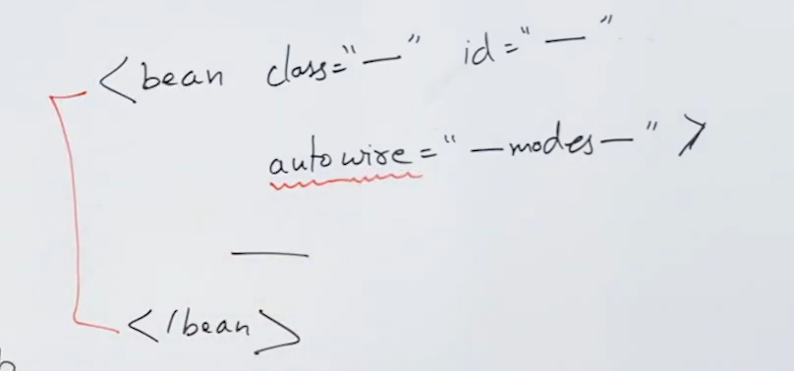

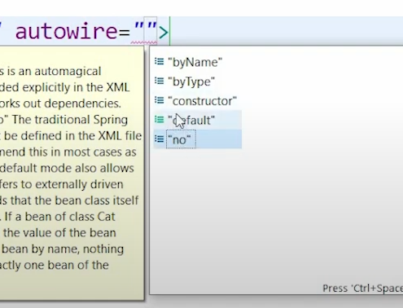

Autowire by Name 🡺

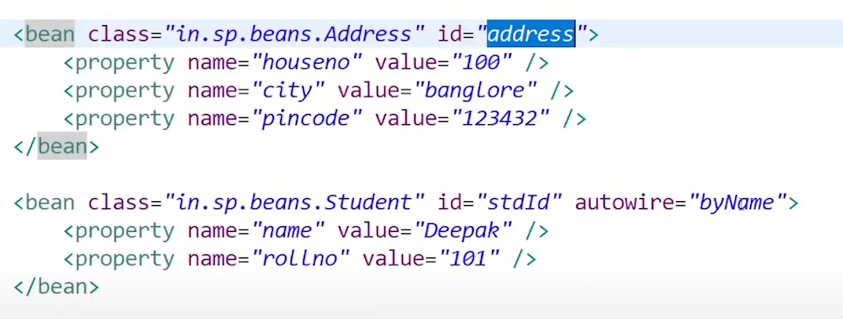

byName mode internally uses setter methods

Autowire by Type 🡺

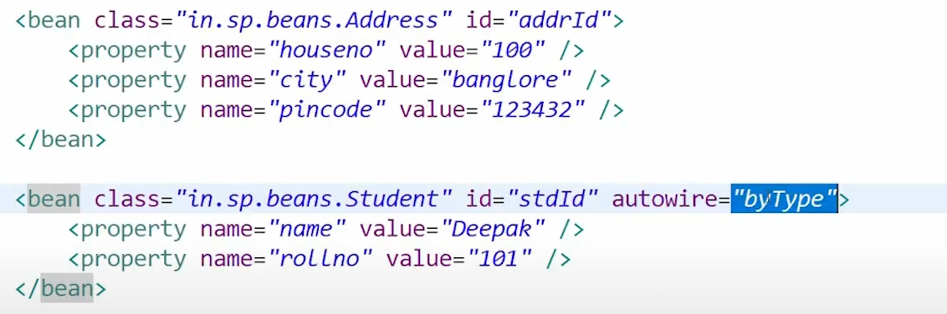

Auto wire candidate false is used to tell that this bean object will not be participating in auto wiring

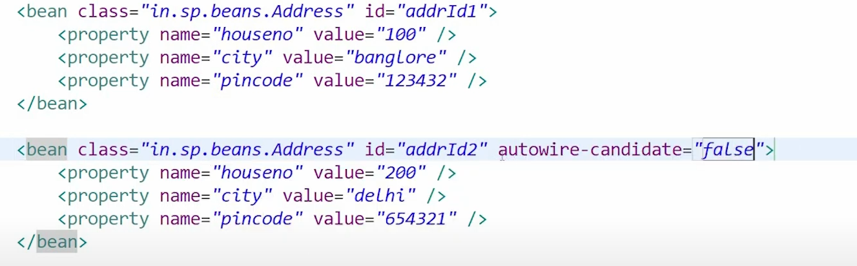

Auto wiring using constructor in xml : here we also have to add indices

